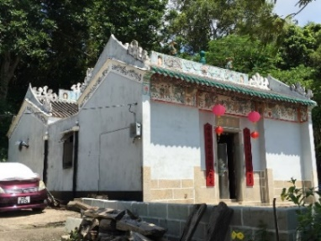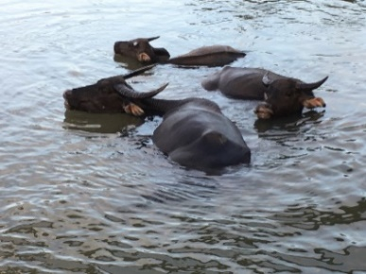

Lantau Hiking Trip and Tea with the Bunkers
Meeting Date: Saturday 12 November 2016
Meeting Location: Central Ferry Pier No. 6 at 11:40am (Alternatively meet at Pui O outside the La Isla Variety Store at 12:50 pm)
Cost: HK $ 100 per person plus your own ferry and bus fares.

Once again the Bunkers have very kindly invited us to their home for tea after a walk. This year we shall be tackling a third route to reach their home. The walk will start at 1:00 pm from the Pui O village. Peter Stuckey will be leading the walk and be meeting at 11:40 a.m. at the Central Ferry Pier No.6. He will give us brief talks on the highlights of our trip, particularly about the feral cattle resident at Pui O, the Tin Hau Temple at Pui O beach and the coastal scenery along the way.

The walk is around 8 kms on concrete paths and fairly well made tracks, mostly contoured. It involves no prolonged steep climbs. However, it will take about 3 hours of walking and once started there are no easy exit options except to complete the walk. Suitable clothing and shoes are essential. Be sure to bring water.

The Bunkers have kindly invited us for one of Sally Bunker's excellent cream teas at their delightful home in Mui Wo after the hike. Participants can make their own way home from there via the regular ferry services or buses.

There is a maximum of 32 participants so do sign up early.

Enquiries: | Herman Yong, mobile: 852 9401 8335 email: herman@onepac.net
Booking Form for Lantau Hiking Trip and Tea
Full name:
University and College:
Contact telephone number:
E-mail address:
Number of attendees:
HK$
Payment Method Options:
Online: Please pay through this link below:
https://www.eventbrite.hk/e/lantau-hiking-trip-and-tea-with-the-bunkers-tickets-28316183467

Cheque: Please send booking form and a cheque for the total amount payable to “The Oxford and Cambridge Society of Hong Kong” to: Kenneth She, P. O. Box 2397, General Post Office, Hong Kong SAR, China.
Consider your booking successful unless you hear otherwise from us.

